Recognized pattern: FakeDoc_variety1

The form of the pattern:

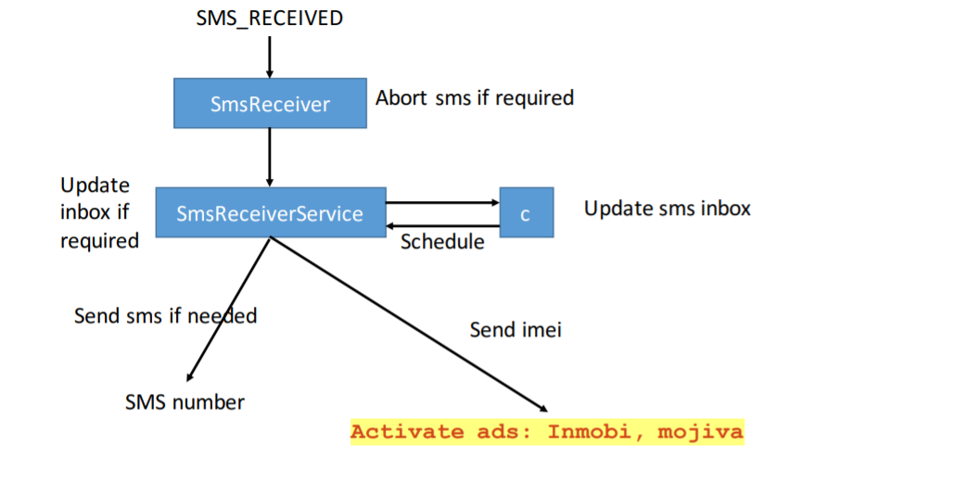

Name of Sample app: Battery SuperCharger

The name of this app: Prepay Credit

For functional modules:

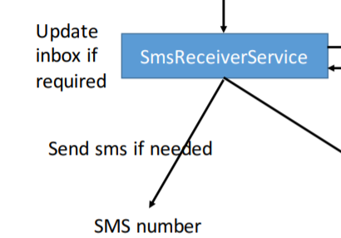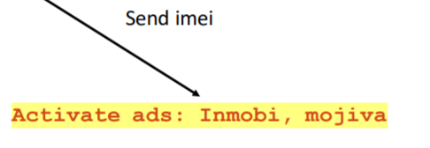

Corresponding to the key code in sample app:

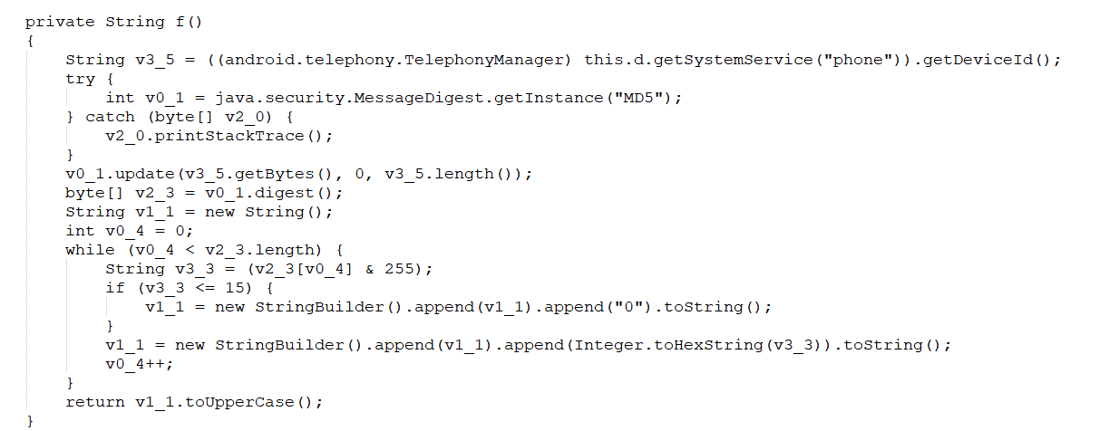

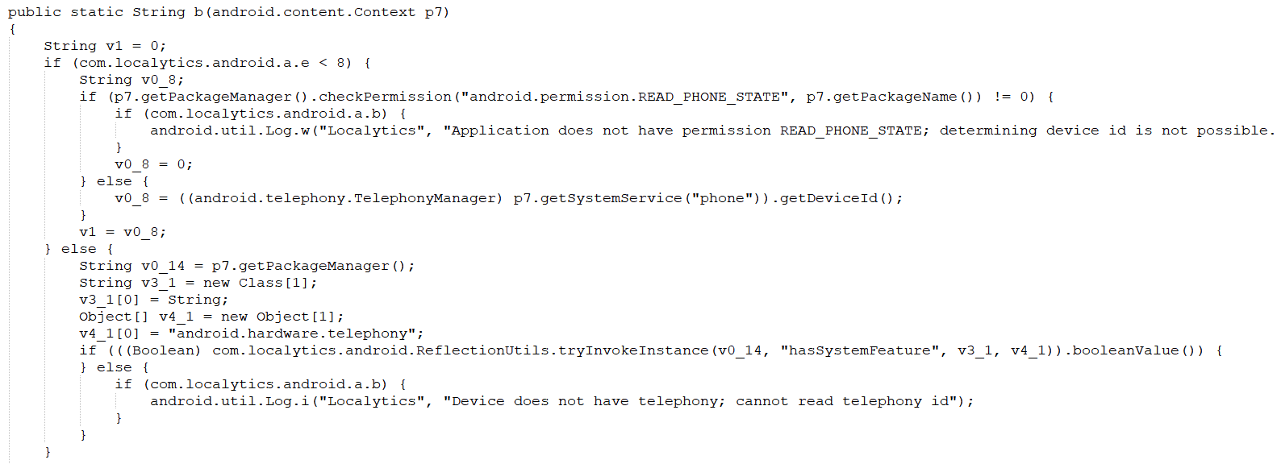

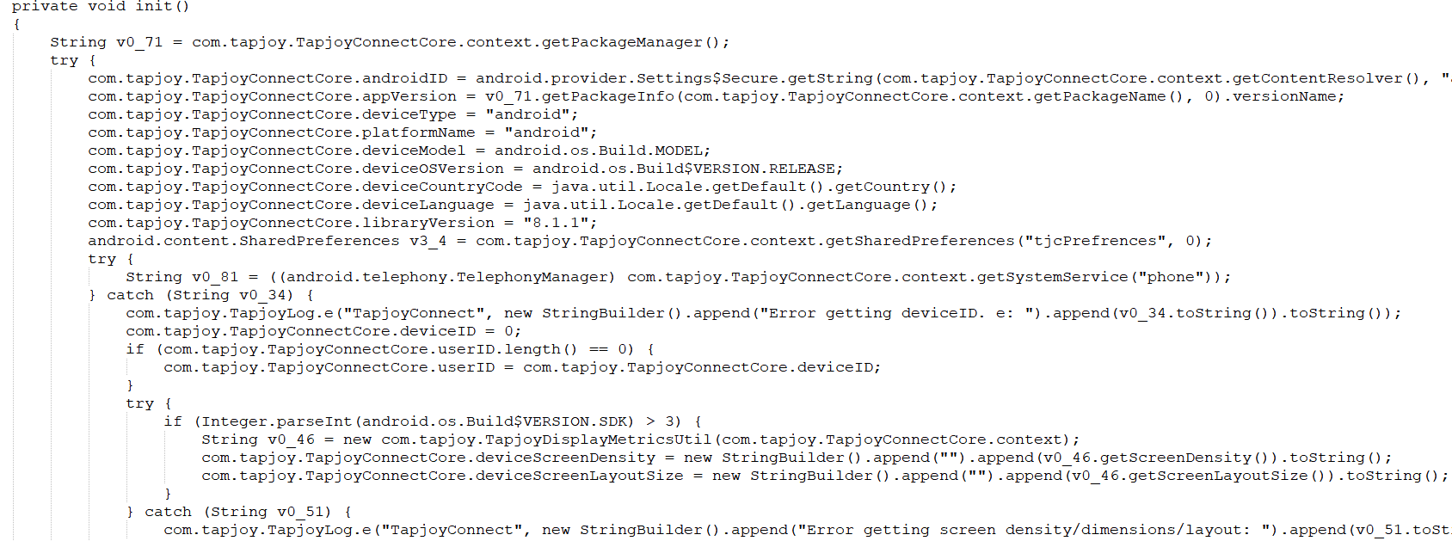

Corresponding to the key code in this app:

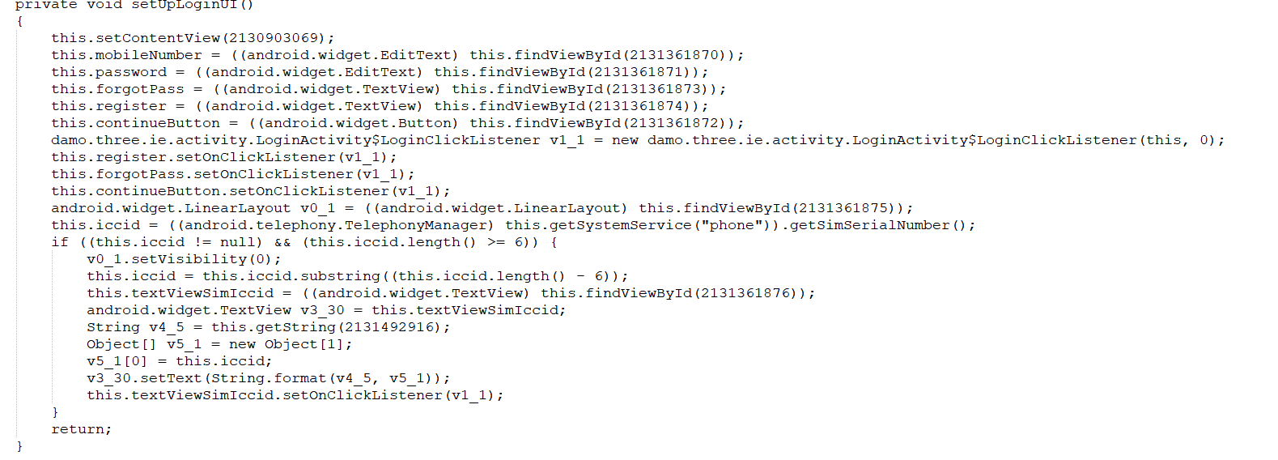

For the function module (schedule)

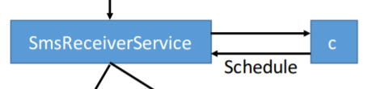

Corresponding to the key code in sample app:

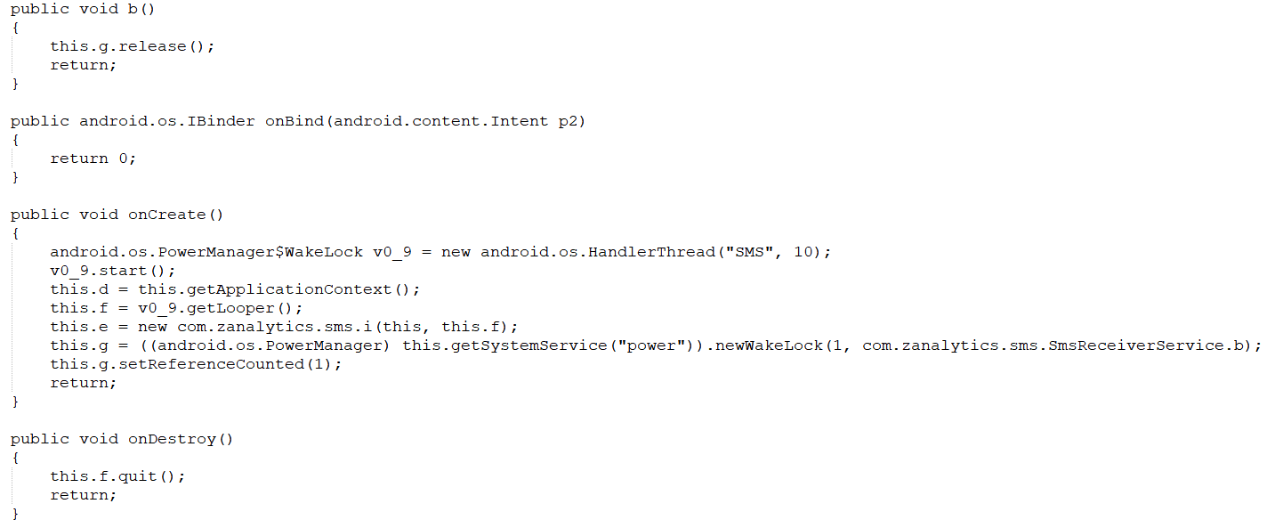

Corresponding to the key code in this app:

